Databases Assignment 4

Part I Linear regression:

Added features: We have added two features, the “University” a number between 1 and 3, 1 for Ariel, 2 for Ivrit, 3 for Technion. And the “Nationality” a number between 1 and 3, 1 for Russia, 2 for France, 3 for Israel.
The features have been added arbitrary, without worried about the real. Which mean that adding this information doesn’t mean an improvement of the prediction of the salary.
As a result we conclude : adding features do not improve the error cause the features we add are not relevant, and not based on the real life.
We here show that wrong information are detected. See on the ScreenShots folder the screenshot which show the output of the linear regression and the two error.

Part II logistic regression:

added features: We have added two features, “Management” a binary indicator which is 1 when salary is >=30k and “Junior” when salary<=20k
We tried to make the features informative and helpful but the names\meanings are of course arbitrary (tough features added artificially are considered noise in our opinion more then features).
We have had mixed results regarding the helpfulness of the added features, probably because the data set was too small.

With normalization and without added features:
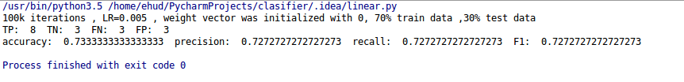
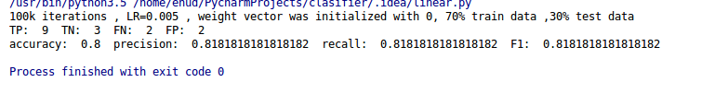
with added features and normalization:

